1. 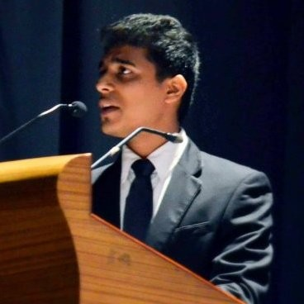

Raghav Mittal

Batch of 2015

Founder of Finance and Economics Club

Currently working as : Investment Professional at Locus Investment Group (Gurgaon)

LinkedIn : <https://www.linkedin.com/in/raghavmittal31/>

2. 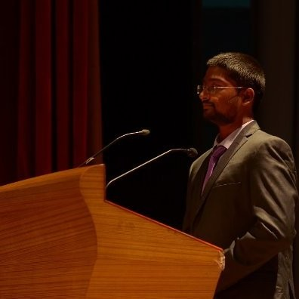

Om Prakash Reddy

Batch of 2015

Currently working as : AVP, Product at QuantMagnum Technologies

LinkedIn : <https://www.linkedin.com/in/thaduru/>

3. 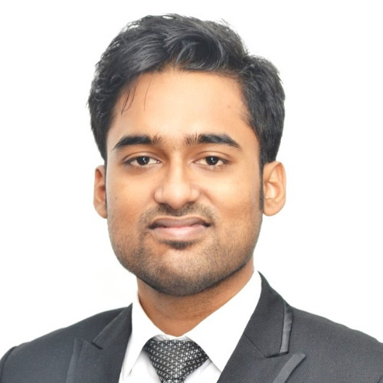

Saurav Mohanty

Batch of 2016

Secretary of Finance and Economics Club (2015-16)

Currently working as : Senior Associate at Boston Consulting Group

LinkedIn : <https://www.linkedin.com/in/saurav-mohanty-a0134197/>

4. 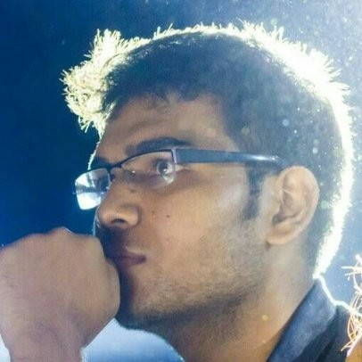

Shashank Gautam

Batch of 2018

Secretary of Finance and Economics Club (2016-17)

Currently Working as : Software Engineer Associate at Symantec

LinkedIn : <https://www.linkedin.com/in/shashankg14/>

5. 

Nihar Lohiya

Batch of 2018

Currently Working as : Management Trainee at Ola

LinkedIn : <https://www.linkedin.com/in/niharlohiya/>

6. 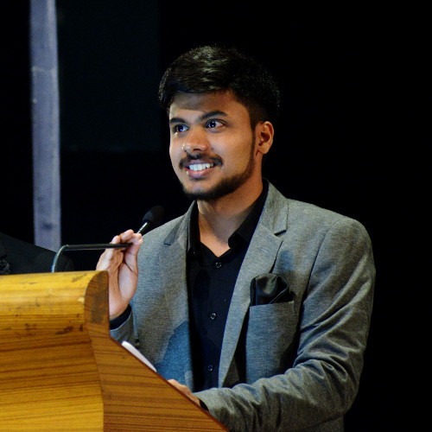

Jaya Singh

Batch of 2018

Core Team Member of FInance and Economics Club (2016-17)

Currently Working as : Member of Technical Staff at Adobe

LinkedIn : <https://www.linkedin.com/in/jayasingh2/>